**COMSATS University Islamabad, Abbottabad Campus**

**Department of Computer Science**

**Project Proposal**

**Blood Donation Management System**

**CSC392 Object Oriented Software Engineering**

Submitted on: <Date&Time>

Group Members:

Waleed Khan (SP21-BSE-026)

Ahmed Bajwa (FA20-BSE-169)

Tayyab Rafique(SP21-BSE-024)

Table of Contents

CHAPTER 1 PROJECT PROPOSAL 3

Introduction 3

Vision and Business Case 3

Use-Case Model 3

Supplementary Specification 3

Glossary 3

Risk List & Risk Management Plan 3

CHAPTER 2 USE CASES 4

Use Case Diagram 4

Brief Level Use Cases 4

Student Name 1 (Registration Number 1) 4

Student Name 1 (Registration Number 1) 5

# CHAPTER 1 PROJECT PROPOSAL

## Introduction

Blood donation system is a system where different categories of people donate their blood To the needy person across the country. People will store their information on the system i.e. their mobile number, NIC number, blood type, medical history etc. and the system then scan for the appropriate person who fits the description and match the pair. The donor will be informed right after the blood has been donated. Also some verification will also be made on the person who needs blood incase of any misinformation provided by him to the system. The donor can set his data public or private. Incase he doesn’t want to be traced. Blood donation bank will also play an important role as all the blood will be stored in the bank.in case a person requires more blood then he will pay for the blood, the poor and needy person will be given free blood. In the end if the person had successfully recovered from an illness due to the blood donated to him then he can also give something (present)to the donor as a good gesture.

## Vision and Business Case

## Vision

The vision is To become the leading world class blood system in the innovation of new services, technology and research that positively impacts blood product safety and availability and enhances the live of our team members. The system makes the overall project management much easier and flexible.

***executive summary***

It is a blood donation management system which will serve human by automating the process of blood donation .It will consist of a website which will be connect to all blood donation center and a database to add blood, record blood donation history ,doner medical back ground as well as the patent record who are in need of blood in emergency cases or on regular bases(thalassemia patent) in addition to this there will be a reward system which will provide rewards for the doners

***the high-level goals and constraints***

|  |  |  |  |
| --- | --- | --- | --- |
| High-level Goals | Priority | Problems and Concerns | Current Solutions |
| Fast, user friendly, blood management system | High | Website link down in case of high use.  Lack of up to date accurate information from database and other blood donation centers due to non synchronization |  |

***the business case***

* Donor Management: Doner will donate blood which will be managed by blood donation management system
* Seeker Management: Seeker will request blood donation management system for a particular blood type which will be required by them
* Donation Management: this module will contain the list of donors along with the blood type that is donated by them.
* Stock Management: This module will deal with the all types of blood which are currently store in the repository of blood donation management
* Receiver List Management: this module deal with the all the person list that has successfully received the blood that was required by them.
* Reward Management: In this module it will manage the reward system of blood donation management.

## Use-Case Model

* Login: it will perform the local login function
* Registration: it will perform the local login function
* Manage System: it will manage the whole blood donation management system
* Donate Blood: Donate blood will enable the donor to donate blood
* Conduct Test: Conduct test function is a function through which donor will be able to test his blood before donation
* Request Blood: Request blood is a functionality of BDMS where a certain type of blood will be requested
* Accept Request : BDMS have a functionally of accepting blood request from a particular seeker
* Check Emergency: BDMS will gather circumstances through this feature under which blood is requested
* Check Donor List: This feature will enable BDMS to check donor list incase of emergency situation
* Check Stock: Check stock feature will enable BDMS to check the stock of blood bank
* Adding Receiver in list: This feature will be used to maintain the list of all the seeker that have received the blood in the database of BDMS
* Managing reward: this feature will manage the information of rewards that have been received by the donor

## Supplementary Specification

* Free blood must be given to the needy and poor person
* Donor and the seeker must be in range
* Text should be bold and clear
* Text must be visible from 1 meter.
* Result should be displayed within 30 seconds 90% of the time
* Text should be bold and clear

## Glossary

* Blood BDMS

## Risk List & Risk Management Plan

# Getting Doner and seeker in range: doner and seeker will be linked by identifying their current location

# Getting the right blood type to the right person: person will be identified through some verification process

# Getting authentic blood info: blood information will be verified by conduction blood test

# Verifying the donor information: donor information will be identified by the documents submitted by them

# Management of blood bank stock : blood bank stock should be kept up to date and manage by a data base system

# Management of rewards: rewards should be managed by process so that the right donor gets the reward

# CHAPTER 2 USE CASES

## Use Case Diagram

## Brief Level Use Cases

### Waleed Khan (SP21-BSE-026)

#### Use Case 1: Check Donor list

The seeker ask for a particular blood type. Then the BDMS search for that particular blood the blood bank if it is not available then it will search in the other blood banks at the End the Admin will search in the Data base of the DBMS if no blood is found in the blood bank. The admin will then search for the same blood group type donor. the blood group type donor is found and he is also eligible to donate blood. The donor will be requested to donate blood . the donor will willingly donate blood at the near blood bank which will further be delivered to the seeker

#### Use Case 2: Donate Blood

Registered donor can willingly donate blood in the blood bank whenever they want . Some Donors are requested to donate blood incase of emergency. If the blood bank has not a particular blood and it is needed then the donor will be requested to donate it. The donor will go to the nearest blood bank available and donate blood.

Mattiallah Safi (Sp21-bse-030)

*Use case1: Manage System*

The admin will manage the system including all the users Donor, Seeker and the Blood bank to add a user or Delete from the system or update his/her detail including his blood group info address, contact etc.

*Use case 2: Check Stock*

When the seeker request for blood the Blood bank will first check it in the stock, Is it available or short if the demanded blood is short then they contact other bank or for donor, search in the donor list to ask him/her for donation of the blood and for the next time they will full their stock.

Fully Dressed Use Cases

### Waleed Khan (SP21-BSE-026)

| Use Case UC1: Check donors list |
| --- |
| **Scope**: Blood donation management system  **Level**: user goal  **Primary** **Actor**: Admin  **Stakeholders and Interests**:   * Donor : donor will get to donate blood if he is willing and eligible * Receiver: receiver will get the blood which is needed * Admin: wants to run things between donor and seeker so admin will make sure that donor get to donate blood and seeker receives the blood   **Preconditions**: When the blood is requested from the receiver side then blood bank will check to see if that particular blood type is present in the bank and if the stock has no such blood type then this use case will be initiated where the blood bank will see for a eligible donor. . |

**Success Guarantee** (or Postconditions): After successful completion of the use case the list of all the relative blood type donor will be displayed

**Main Success Scenario (or Basic Flow):**

1. Admin search for a donor with a particular blood type
2. A list is shown of donors
3. One particular donor is selected
4. All the details are shown against that particular donor

**Extensions (or Alternative Flows):**

* Admin check for blood in the storage and the blood is available
* Admin search for a donor and does not found an eligible donor
* Donor is found but his 4 months of last donation are not completed

**Special Requirements:**

* Donor can donate blood after every 4 months
* Free blood must be given to the needy and poor person
* Donor and the seeker must be in range
* Text should be bold and clear
* UI should have elements on the appropriate places
* Text must be visible from 1 meter.
* Result should be displayed within 30 seconds 90% of the time.

**Technology and Data Variations List**:

Admin can search the donor list on the website while logged in using his password and username given to him.

**Frequency of occurrence:**

Could be nearly continuous .

**Open Issues:**

* -Is the donor eligible ?
* Is the donor willing to donate blood
* If the donor is located will he be in range of the seeker
* How the seeker will get the blood

**Screen Shot:**

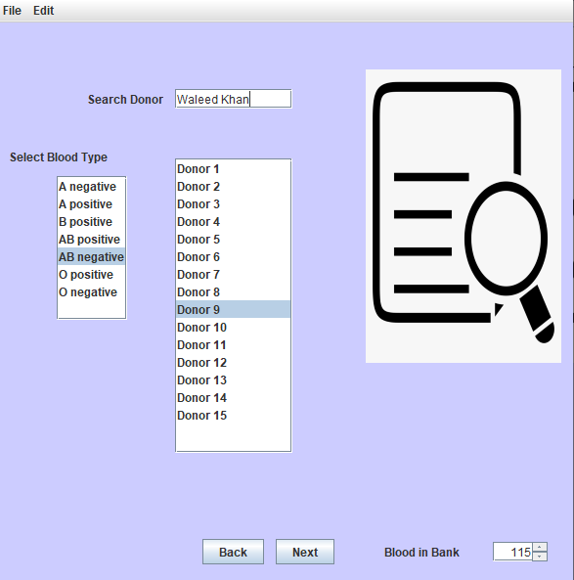

#### Use Case UC2: Donate Blood

| **Scope**: Blood donation management system  **Level**: user goal  **Primary** **Actor**: Donor  **Stakeholders and Interests**:   * Blood banks: blood bank get the blood for storage which will be put to use later. * Receiver: Receiver receives the blood which is required by the receiver. * Donor: Donor gets to donated blood as he is willing to donate in   **Pre-condition:**  The seeker or blood bank can request donor to donate blood or the donor can also donate blood without request the pre condition is if the donor is legible for a blood donation i.e. after how long the donor is donating the blood the condition is that he can only donate blood after 4 months since he last donated. |
| --- |

**Success Guarantee** (or Postconditions): Successful outcome of the use case will be that the donor will be able to donate blood

**Main Success Scenario (or Basic Flow):**

1. Blood bank search for eligible donor
2. Blood bank finds eligible donor
3. Donor is notified to donate blood
4. Donor successfully donates blood

**Extensions (or Alternative Flows):**

* Donor cant donate blood because his last donation has not completed 4 months
* Donor is legible but is not willing to donate blood

**Special Requirements:**

* Text should be bold and clear
* UI should have elements on the appropriate places
* Text must be visible from 1 meter.
* Result should be displayed within 30 seconds 90% of the time.

**Technology and Data Variations List**:

Donor will be notified if he is needed for the blood or he can donated willingly on the system by sending a message.

**Frequency of occurrence:**

Possibility after every four months.

**Open Issues:**

* Can donor donate before his 4 months completion
* Is the donor eligible for the blood donation
* How will the donor donate blood
* How will seeker get blood
* How it will be known if the seeker is truly needy for the blood.

**Screen Shots:**

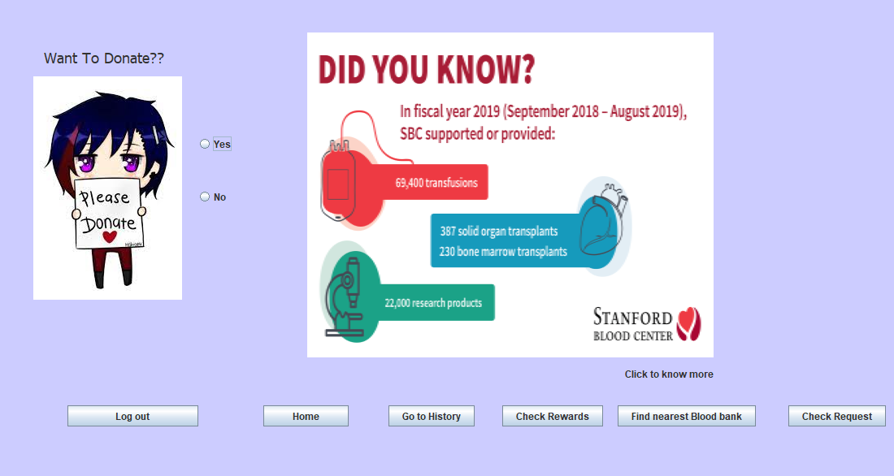

End of My use case(SP21-BSE-026)

Fully Dressed Use Cases

Ahmed Imtiaz Bajwa (Fa20-Bse-169)

Use Case 1: Reward System

|  |  |
| --- | --- |
| **Use Case Section** | **Comment** |
| **Use Case Name** | Reward System |
| **Scope** | NextGen blood donation management system |
| **Level** | User goal |
| **Primary Actor** | Admin |
| **Stakeholders and Interest** | Admin wants Accurate delivery of reward to doner |
| **Preconditions** | Seeker has requested to give a reward to doner |
| **Success Guarantee** | Seeker reward request has accepted, reward has been collected and deliver or hand over to the correct doner |
| **Main Success Scenario** | 1.seeker arrives at the reward center,  2.Admin adds the reward data.  3.It is saved by the system.  4 System presents a receipt.  5.seeker leaves with the receipt.  6.Reward is delivered to the doner. |
| **Extensions** | At any time, admin can override the operation |
| **Special Requirements** | Touch screen UI on a large flat panel monitor. Text must be visible from 1 meter. |
| **Technology and data Variations List** | Admin can enter the system using an OTP |
| **Frequency of Occurrence** | Could be nearly continuous |
| **Miscellaneous** | Any problem |

When the seeker wants to give a reward to the donor. A form will be shown to him in which he will write all the details of the event when was blood given what was the case and who was the doner and what will be the reward .it will be approve by the admin and the reward will be deliver to the doner.

|  |
| --- |

Use Case 2: Check Emergency

In case of emergency the blood will be delivered to the seeker as soon as possible. The seeker will request blood in emergency type it will be top priority of the admin to deal with this request first .and try to deliver blood as soon as possible.

|  |  |
| --- | --- |
| **Use Case Section** | **Comment** |
| **Use Case Name** | Check Emergency |
| **Scope** | NextGen blood donation management system |
| **Level** | User goal |
| **Primary Actor** | Admin |
| **Stakeholders and Interest** | Admin wants Accurate and fast delivery of blood to seeker |
| **Preconditions** | Seeker has requested blood of emergency type |
| **Success Guarantee** | Seeker blood request has accepted, blood has been collected and deliver or hand over to the correct seeker as soon as possible |
| **Main Success Scenario** | 1.seeker arrives at the reward center, or website.  2.seeker adds the blood details.  3.System checks the availability of blood.  4.if it’s available the system ask the way of delivery and if it is not it will notify the admin.  5.seeker enter the details for delivery.  6.record has been added to the system. |
| **Extensions** | At any time, admin can override the operation |
| **Special Requirements** | Touch screen UI on a large flat panel monitor. Text must be visible from 1 meter. |
| **Technology and data Variations List** | Admin can enter the system using an OTP |
| **Frequency of Occurrence** | One a while |
| **Miscellaneous** | Any problem |

|  |
| --- |

Screen Shots

